**Communication between applications in Docker**

* Let’s establish container connectivity for the nopCommerce  
  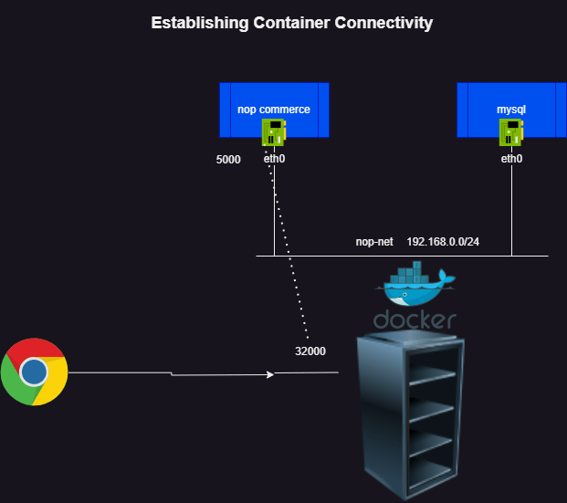
* Let’s quickly write a Dockerfile for nopCommerce

FROM alpine:3.18.2 AS extractor

ARG DOWNLOAD_URL="https://github.com/nopSolutions/nopCommerce/releases/download/release-4.60.3/nopCommerce_4.60.3_NoSource_linux_x64.zip"

ARG TARGET_FOLDER="/nop"

ADD ${DOWNLOAD_URL} ${TARGET_FOLDER}/nopCommerce_4.60.3_NoSource_linux_x64.zip

RUN apk update && \

apk add unzip && \

cd ${TARGET_FOLDER} && \

unzip nopCommerce_4.60.3_NoSource_linux_x64.zip \

&& rm nopCommerce_4.60.3_NoSource_linux_x64.zip && \

mkdir bin logs

FROM mcr.microsoft.com/dotnet/sdk:7.0

LABEL author=khajaibrahim

ARG TARGET_FOLDER="/nop"

ENV ASPNETCORE_URLS="http://0.0.0.0:5000"

COPY --from=extractor ${TARGET_FOLDER} ${TARGET_FOLDER}

EXPOSE 5000

WORKDIR ${TARGET_FOLDER}

CMD ["dotnet", "Nop.Web.dll"]

* Create a docker image with name nop:4.60.3
* Lets create a bridge network with cidr range 192.168.0.0/24  
  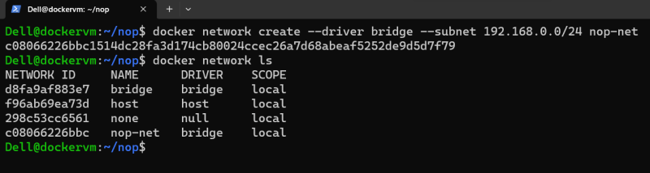
* Let’s create a mysql container with on nop-net network
  + username => nop
  + pwd => nop@123
  + root password => nop@123
  + database name => nopdb

docker container run --name nopdb -d -e MYSQL_ROOT_PASSWORD=nop@123 -e MYSQL_DATABASE=nopdb -e MYSQL_USER=nop -e MYSQL_PASSWORD=nop@123 --network nop-net mysql:8

* Let’s inspect ip address for this container

docker network inspect nop-net

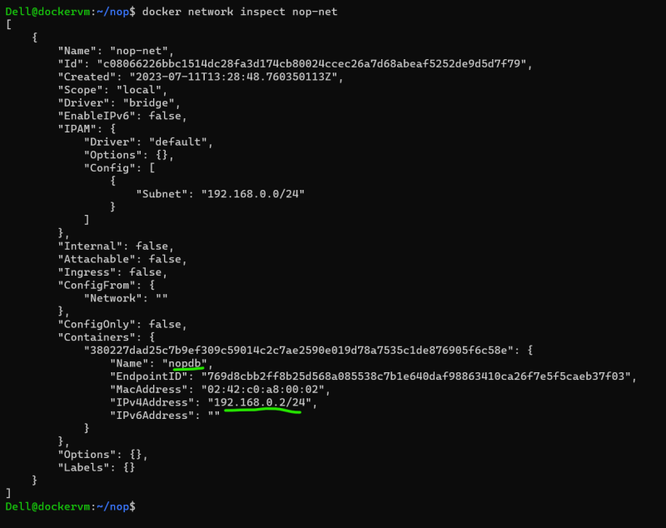  
* Note: when you practice ensure you create and mount volume  
* Let’s try creating nop container in the same network

docker container run -d --name nop1 --network nop-net -p 32000:5000 nop:4.60.3

* Let’s inspect network again  
  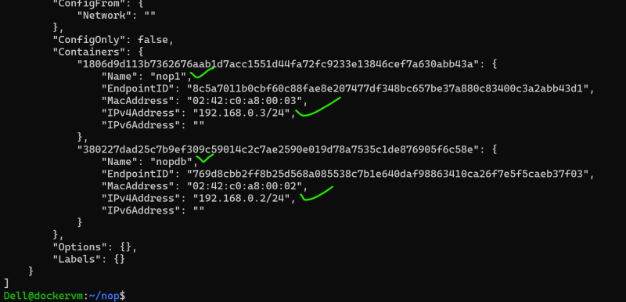
* Now lets configure the application by accessing it  
  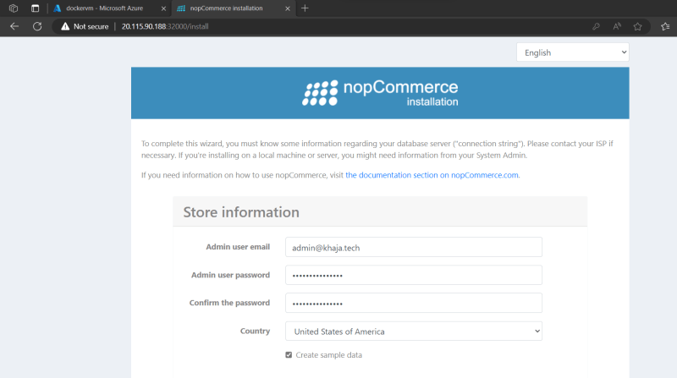
* Now enter the data base details  
  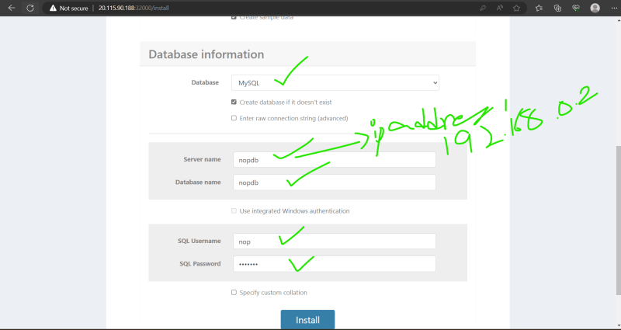
* Once the installation is complete the nop container will be stopped, kindly start it
* Now access the application  
  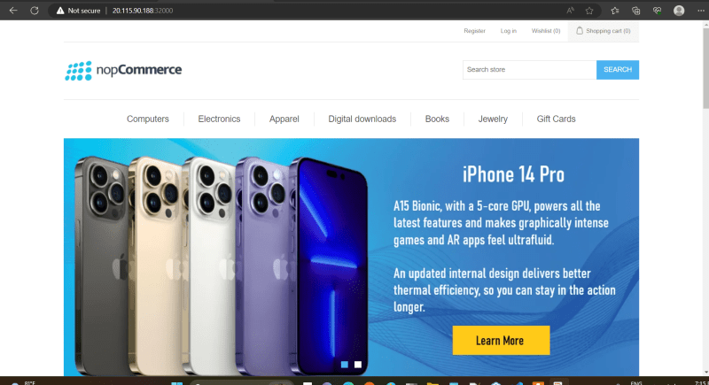

**Docker Compose**

* Lets try running nop commerce in a system in easier way
* consider the nopCommerce code from here <https://github.com/CompleteKubernetes/nopCommerceJuly23>
* <https://github.com/CompleteKubernetes/nopCommerceJuly23/commit/152e730fb9d95a8bbed10691c59a12fb1146f72b> for the yaml file created
* Clone the git repo and cd into it
* Then execute

git checkout compose_intro and docker compose up -d

